Project Design Phase-II

Data Flow Diagram & User Stories

Date | 9 March 2026
Project Name | Malaria Detection using Deep Learning
Maximum Marks | 4 Marks

Data Flow Diagrams:

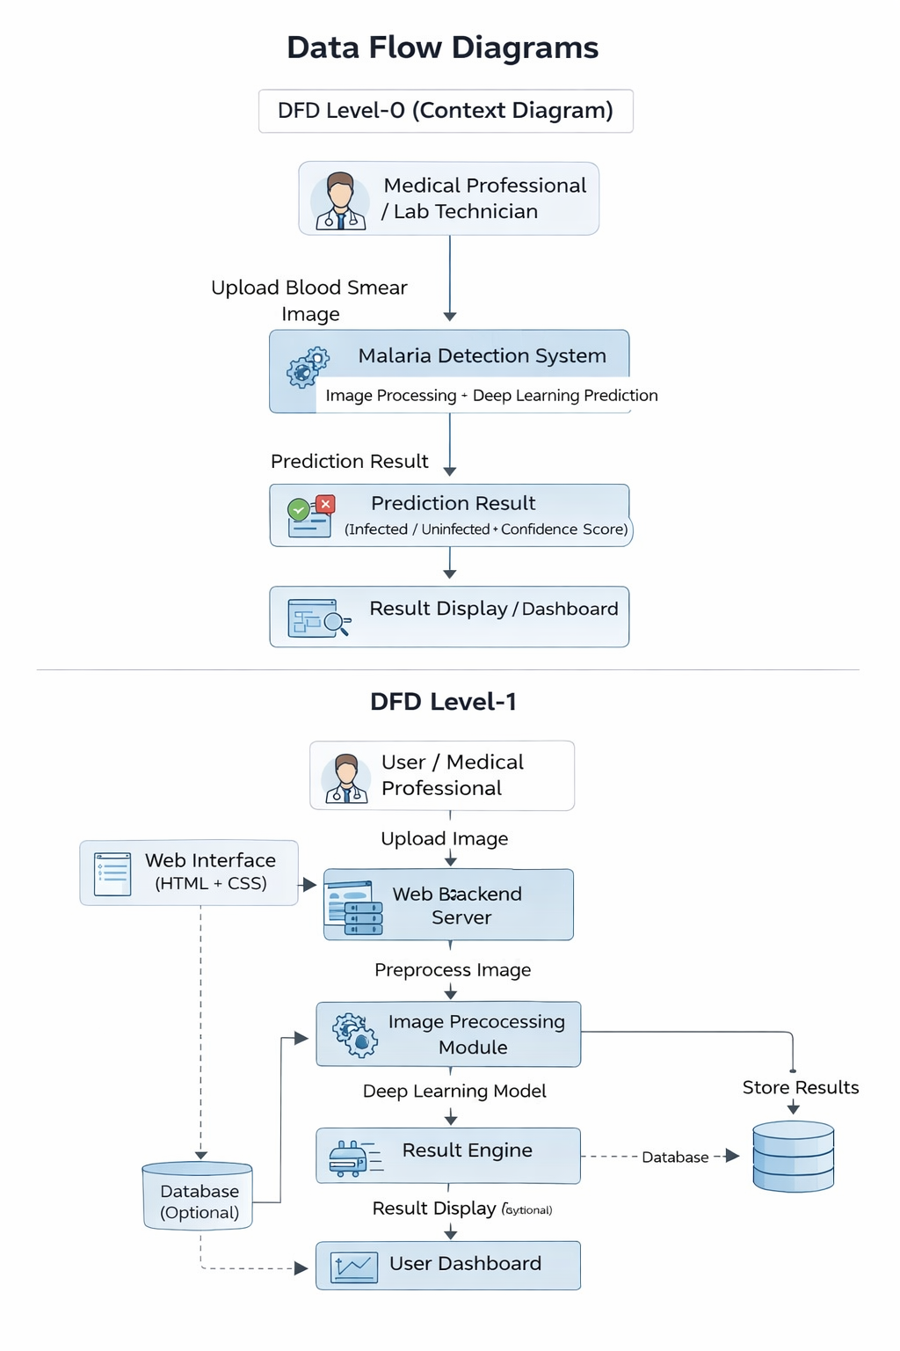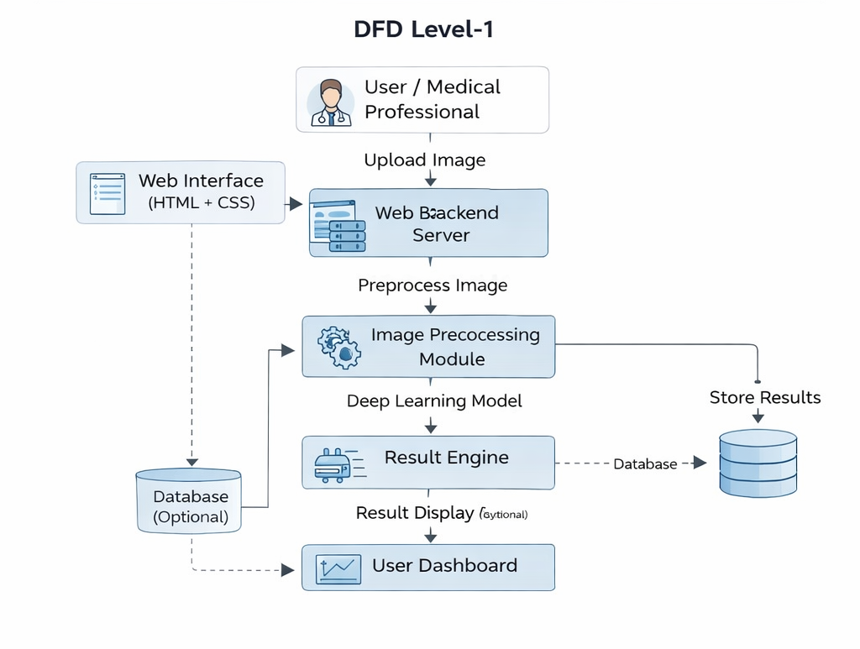

User Stories

User Type | Functional Requirement (Epic) | User Story Number | User Story / Task | Acceptance Criteria | Priority | Release
Medical Professional | Image Upload | USN-1 | As a user, I can upload a blood smear image for malaria detection. | The system accepts image upload successfully. | High | Sprint-1
Medical Professional | Image Processing | USN-2 | As a user, I want the system to preprocess the uploaded image automatically. | The image is resized and prepared for model input. | High | Sprint-1
Medical Professional | Malaria Detection | USN-3 | As a user, I want the system to analyse the uploaded image using AI. | The deep learning model processes the image and detects malaria. | High | Sprint-1
Medical Professional | Prediction Result | USN-4 | As a user, I want to see whether the image is infected or uninfected. | The system displays classification results. | High | Sprint-1
Medical Professional | Confidence Score | USN-5 | As a user, I want to see the confidence score of the prediction. | The result includes prediction probability. | Medium | Sprint-2
Medical Professional | Dashboard | USN-6 | As a user, I want to view previous detection results on a dashboard. | The system displays analysis history. | Medium | Sprint-2
Administrator | System Monitoring | USN-7 | As an administrator, I want to monitor system performance and predictions. | Admin can access system analytics. | Low | Sprint-3

